**Theory and Design**

A **Healthcare and Medical Website** is a digital platform designed to provide medical information, healthcare services, patient support, and other health-related functionalities. These websites can be built for hospitals, clinics, medical professionals, or health-tech companies and can serve various purposes, such as appointment booking, telemedicine, patient records management, and health education

1. **Login Page**

The user needs to enter the name and phone number to login .

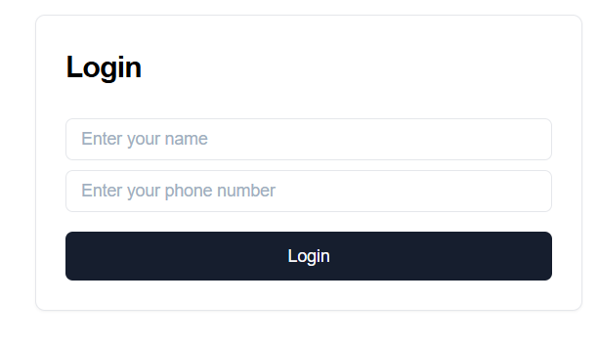

1. **Chat area**

The user can now chat with the Doctor tell him the problem and then will get the solution accordingly .

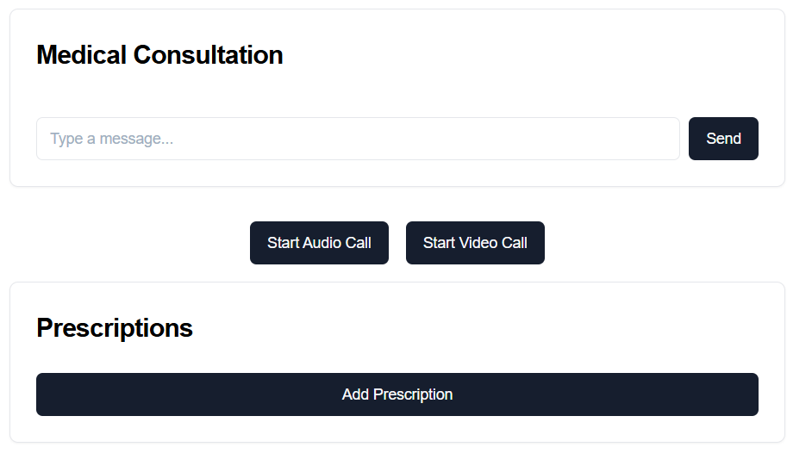

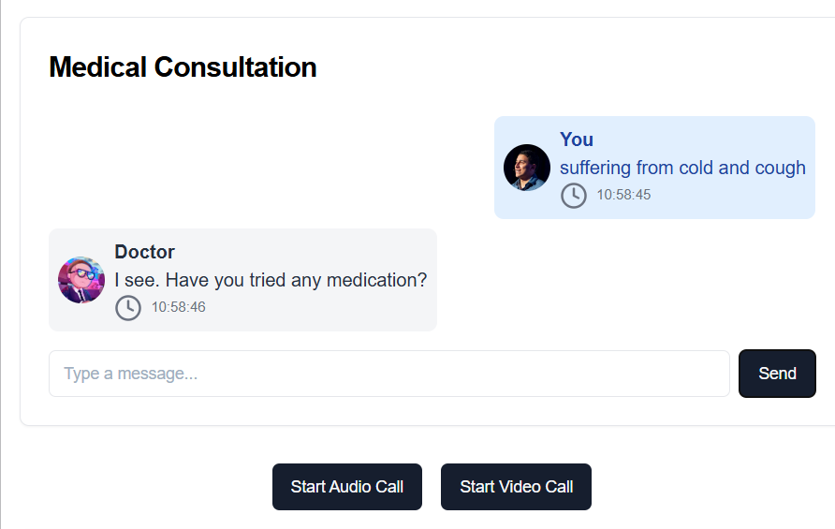

1. **Audiocalls and Videocalls Facility**

It provides the facility of chats, audio and video calls , The user can choose the mode of communication according to his/her comfort .



1. **Prescriptions**

One can download the prescription online and also the old prescriptions will be there in archives which will be helpful for both the doctors and the patients .

